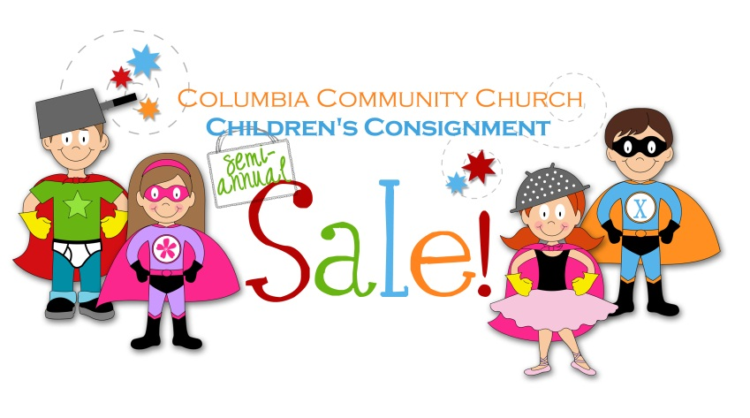
Consignor #

Car Seat Waiver
Put your consignor number in the box above. In order to sell a car seat at Columbia Community Children’s Consignment Sale, you must meet all five of the following requirements. Please check [T] for true and [F] for false.
T F
[ ] [ ] You are the original owner of this car seat.
[ ] [ ] This car seat has never been in an accident.
[ ] [ ] None of the parts of this car seat have been broken.
[ ] [ ] This car seat is less than five (5) years old (check the manufacturer’s
label on the back of the car seat).

[ ] [ ] You have verified that this car seat is not under recall.
(by calling 1-800-424-9393 or visiting www.cpsc.gov).

- If you answered “false” on any of these requirements, then you cannot submit this car seat for sale at Columbia Community Children’s Consignment Sale.
- If you answered “true” on all five of the requirements, then sign and date this waiver on the lines below.

Printed Name of Consignor

Consignor’s Signature

Today’s Date

